UNIVERSTY OF MUMBAI

PROJECT REPORT ON

Employee Management
System

SUBMITTED

BY

VIKRAM SURAJ PAL



DTSS COLLEGE OF COMMERCE

UNDER THE GUIDANCE OF
Prof. UTKARSHA.BHAT

M. Sc. IT [2024-2025]

Certificate
Department of It-data science

Ref No: Date:
CERTIFICATE

This is to certify that the project entitled EMPLOYEE MANAGEMENT SYSTEM Undertaken at the D.T.S.S. COLLEGE OF COMMERC & SCIENCE.

By

VIKRAM SURAJ PAL

In partial full filament of M.Sc. IT (Semester III) Examination had not been submitted for any other examination and does not form part of any other course undergone by the candidate.
It is further certified that she has completed all required phases of project.

Signature of Internal Guide
Signature of External

Signature of the co-ordinate

Performa for the Approval Project Proposal

PNR NO: 2020016401575657 ROLL NO: 04

- Name of the Student
- Vikram Suraj Pal

- Title of the Project
- Employee Management System

- Name of the Guide.
- Prof. Utkarsha. Bhat

- Teaching experience of the Guide.
- 15 Years

- Is this your first Submission?

Yes, ____ NO _____

Signature of the student Signature of Guide

Date: - Date: -

Signature of the co-ordinate
ABSTRACT

The actual problem is to maintain different database for an organization whose main purpose is to issue pay-slips for their employees every month working in various departments of the organization, and maintain details of all the departments, employees with various grades, their designations and address details.

In the manual system it is difficult to maintain data and generating different reports according to requesting transaction. In the present system it is becoming difficult to issue pay-slip for the entire employee every month by manually going through the various record of the organization. i.e. the manger has to go through all the records of the organization of various departments of the and find out the employee working in a particular department and go through his grade, and he have to check the employee leaves of that month, his earnings and his deductions along with his pf and all other deduction including his IT and savings. So, to perform all these activities it is becoming difficult the admin/manager every month.

Hence in order to overcome the difficulties of the organization the present system is automated to perform all the activities of the organization.

ACKNOWLEDGEMENT

In performing this project “EMPLOYEE MANAGEMENT SYSTEM”, I had to rake the help and guideline of some respected persons, who deserve our greatest gratitude.

The completion of this assignment gives me much pleasure. We would like to show our gratitude to Prof. Utkarsha. Bhat for giving us a good guideline for project throughout numerous consultations.

We would also like to expand our deepest gratitude to all those who have directly and indirectly guided us in writing this project report.

Many people, especially our classmates and friends itself, have made valuable comments and suggestion on this proposal which gave an inspiration to improve my project.

Here I thank all the people for their help directly and indirectly to complete this project.

Table of Contents

Sr. No | Title | Page No
01 | Introduction | 1
 | 1.1 Abstract | 2
 | 1.2 Objectives | 3
 | 1.3 Purpose | 4
 | 1.4 Scope | 5
02 | Modules | 6
 | 2.1 Admin | 7
 | 2.2 Advantage | 7
03 | Survey of Technology | 8
04 | Feasibility Study | 9
05 | Project Category | 10
 | 5.1 Web Based Application | 10
06 | System Design | 11
 | 6.1 ER Diagram | 11
 | 6.2 Activity Diagram | 12
 | 6.3 Class Diagram | 13
 | 6.4 Use Case Diagram | 14
 | 6.5 Sequence Diagram | 15
 | 6.6 Data Flow Diagram | 16
 | 6.7 Component Diagram | 17
 | 6.8 Deployment Diagram | 18
07 | Source Code | 19
08 | Screen Short | 29
09 | Features of the Project | 33
10 | Future Scope Of this Work | 34
11 | Conclusion | 35
12 | Bibliography | 36

EMPLOYEE MANAGEMENT SYSTEM

INTRODUCTION

The “Employee Management System” has been developed to override the problems prevailing in the practicing manual system. This software is supported to eliminate and, in some cases, reduce the hardship faced by this existing system. Moreover, this system is designed for the particular need of the company to carry out operations in a smooth and effective manner.

Every organization, whether big or small, has challenges to overcome and managing the information’s of Employee, Employee, Appraisals, Payments, and Working Points. Every Employee Management System has different Employee needs; therefore, we design exclusive employee management systems that are adapted to your managerial requirements. This is designed to assist in strategic planning, and will help you ensure that your organization is equipped with the right level of information and details for your future goals. Also, for those busy executive who are always on the go, our systems come with remote access features, which will allow you to manage your workforce anytime, at all times. These systems will ultimately allow you to better manage resources.

The application is reduced as much as possible to avoid errors while entering the data. It also provides error message while entering invalid data. No formal knowledge is needed for the user to use this system. Thus by this all it proves it is user-friendly. Employee Management System, as described above, can lead to error free, secure, reliable and fast management system. It can assist the user to concentrate on their other activities rather to concentrate on the record keeping. Thus, it will help organization in better utilization pf resources.

1.1 ABSTRACT

The purpose of Employee Management System is to automate the existing manual system by the help of computerized equipment and full-fledged computer software, fulfilling their requirements, so that their valuable data/information can be stored for a longer period with easy accessing and manipulation of the same. The required software and hardware are easily available and easy to work with.

Employee Management System, as described above, can lead to error free, secure, reliable and fast management system. It can assist the user to concentrate in their other activities rather to concentrate on the record keeping. Thus, it will help organization in better utilization of resources. The organization can maintain computerized records without redundant entries. That means that one need not be distracted by information that is not relevant, while being able to reach the information.

The aim is to automate its existing manual system by the help of computerized equipment’s and full-fledged computer software, fulfilled their requirement, so that their valuable data/information can be stored for a longer period with easy accessing and manipulation of the same. Basically, the project describes how to manage for good performance and better services for the clients.

The required software is easily available and easy to work with. This web application can maintain and view computerized records without getting redundant entries. The project describes how to manage user data for good performance and provide better services for the client.

1.2 OBJECTIVE

The main objective of the project on Employee Management System is to manage the details of Employee. Employee, Salary, Appraisals, Working Points. It manages all the information about Employee, Payments, Working Points, and Employee. The project is totally built at administrative end and thus only the administrator is guaranteed the access. The purpose of the project is to project is to build an application program to reduce the manual work for managing the Employee. Employee, Payments, Salary, it tracks all the details about the Salary, Appraisals, Working Points.

To assist ease the works of the Retails Outlet of Any Type of Companies, in particular, Employee Management System is being developed. This would comprise the features that can be operated easily. Employee Management System would take care of the Day-to-day Attendance of All Employee. It covers activities from keeping the details of day to day In, Out, OD etc.

The master and transaction activities are divided in modules so that the activities can be operated easily. The regular backup to the data can be taken and the backup data can be restored effectively. So, the Employee Management System assists the employees of Company in each and every aspect of In and Out. The Employee Management System is customized software and developed according to the needs of Any Type Company.

1.3 PURPOSE

The purpose of this document is to describe the functionality and specifications of the design of a web application for Managing Employees and their Employee. The expected audiences of this document are the developers and the admin of the web application. Now with the help of this system the admin has the information on his finger tips and can easily prepare a good record based on their requirements.

Finally, we can say that this system will not only automate the process but save the valuable time of the manager or the admin, which can be well utilized buy his institute. This will be an additional advantage and management of power based on their free time from his normal duty.

The purpose of the project is to maintain the information regarding the employees and generates the pay slip. Main aim of developing Employee Management System is to provide an easy way not only to automate all functionalities involved managing leaves and Employee for the employee of Company, But also to provide full functional reports to management of Company with the details about usage of leave facility and Salaries Paid or to be paid to employees.

- We are committed to bring the best way to management in the various forms of EPM.
- we understand that EPM in not just a product to be sold, it is a tool to manage the inner operation of Company related to employee leave and Employee.

1.4 Scope

It may help collecting perfect management in details. In a very short time, the collection will be obvious, Simple and sensible. It will be helping a person to know the management of passed year perfectly and vividly. It also helps n current all works relative to Employee Management System. It will be also reducing the cost of collecting the management & collection procedure will go on smoothly.

Our project aims at Business process automation, i.e. we have tried to computerize various processes of Employee Management System.

- In computer system the person has to fill the various forms & number of copies of the forms can be easily generated at a time.
- In computer system, it is not necessary to create the manifest but we can directly print it, which saves our time.
- To assist the staff in capturing the effort spent on their respective working areas.
- To utilize resources in an efficient manner by increasing their productivity through automation.
- The system generates types of information that can be used for various purposes.
- It satisfies the user requirement
- Be easy to understand by the user and operator
- Be easy to operate
- Have a good user interface
- BE expandable
- Delivered on schedule within the budget
02. MODULES

  - Employee Management Module: Used for managing the Employee details.
  - Working Points Modules: Used for managing the details of working Points.
  - Payments Modules: Used for managing the details of Payments.
  - Employee Management Modules: Used for managing the information and details of the Employee.
  - Salary Module: Used for managing the Salary details.
  - Appraisals Modules: Used for managing the Appraisals information.
  - Login Module: Used for managing the login details.
  - Users Module: Used for managing the users of the system.

ADMIN

The admin gets logged in by valid username and password. Admin can add new Employee, add new Department, adds new Pay Grade for the employees. Admin can set the ‘from’ and ‘to’ date worked by an employee in a department with specific pay grade. The admin can generate an automated monthly salary of an employee. The admin can view all the past records of any recorded employee.

ADVANTAGE

- It is cost effective as the user control the web application himself and does not go for professional service.
- It saves time as it speeds up every aspect of the employee database management and Employee process with a range of automated features.
- It is secure as the employee database and the Employee process is managed by the admin in house rather than sending private information to a third party.
- Validating procedures and checks restrict user from making mistakes.
- The software is easy to use and is user friendly so no expertise is required.
- The calculations are automated so no chance of error.

DISADVANTAGE

- It requires an internet connection.
- It requires large database.

03. Survey of Technology

Front end: React.JS, Vite, Node

- React JS: React JS is a JavaScript library used for building interactive and dynamic user interfaces, particularly for single-page applications. It follows a component-based architecture and uses a virtual DOM to enhance performance, making it efficient for modern web development.

- Vite: Vite is a modern frontend build tool that provides a fast development experience by using native ES modules for development and optimized bundling for production. It is lightweight, highly efficient, and significantly reduces startup and build times.

- Node JS: Node.js is a server-side JavaScript runtime built on Chrome's V8 engine, allowing developers to build scalable and fast backend applications. It is designed for non-blocking, event-driven I/O, making it ideal for real-time and data-intensive applications.

Back end: PHP, MySQL

- PHP: Hypertext Pre-processors (PHP) is a technology that allows software developers to create dynamically generated web pages, in HTML, XML, or other document types, as per client request. PHP is open-source software.

- MySQL: MySQL is a database, widely used for accessing querying, updating and managing data in databases.
04. FEASIBILITY STUDY

After identifying the scope of the project, the feasibility study is needed to be carried out. It is basically keeping the following points in mind.

- Building the software for meeting the scope: This software has met the scope. As there is no data involved in the system, processing on the file, and the behavior of this project is already identified and bundled in quantitative manner.
The processing of this software is very simple as it has been designed in php and it has been well divided into several functions according to the need.

- Technically feasible: This software is very much technically feasible. This software is very much concerned with specifying equipment and the software will successfully satisfy almost all the adman’s requirements. The technical need for this system may vary considerably but might include:
- The facility to produce output in a given time.
- Response time under certain conditions.
- Ability to process data at a particular speed

- State of Art: The project is very much within the state of art since the project is a window based; it uses very modern and common technique.

- Beside it is very much modern and user friendly. It also works as middleware.
- i.e. only in between the user and the file. So, it is completely a state of art project.

- Financially Feasible: The project is very much financially feasible. The implementation and development cost of this software under the reach of any college.
Moreover, it requires some training for the use. So, training cost can be neglected and the resources of this software are very much available. It also reduces the labour and extra cost to be paid for labor. So indeed, it is financially feasible.

- Resources: As motioned earlier that the resources are easily available and the cost of training is almost negligible. Sometimes situations may arise when it may not be so much easy. For a person completely unaware of using a computer system could result in a training cost or for a very small organization the purchase of a computer, instalment of the system and other charges may lead to a difficult matter.

05. PROJECT CATEGORY

  - WEB BASED APPLICATION

Available Technologies:
Languages: React JS, Vite, Node JS
Database: MYSQL, PHP

Tools Used:
Editor Used: Visual Studio
Operating System: Windows 11

Hardware Used:
Processor: Intel core i5
RAM: GB
Hard Disk: 1TB

06. SYSTEM DESIGN

- 6.1 Entity Relationship Diagram (ERD):

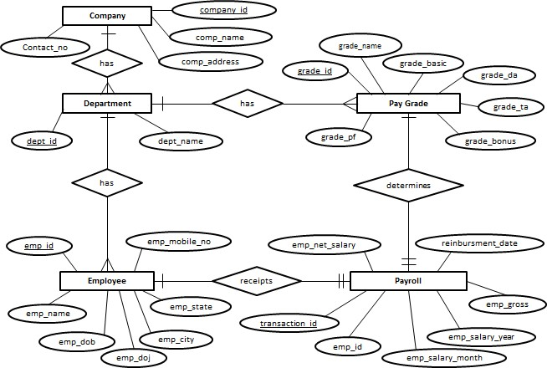

- 6.2 ACTIVITY DIAGRAM:



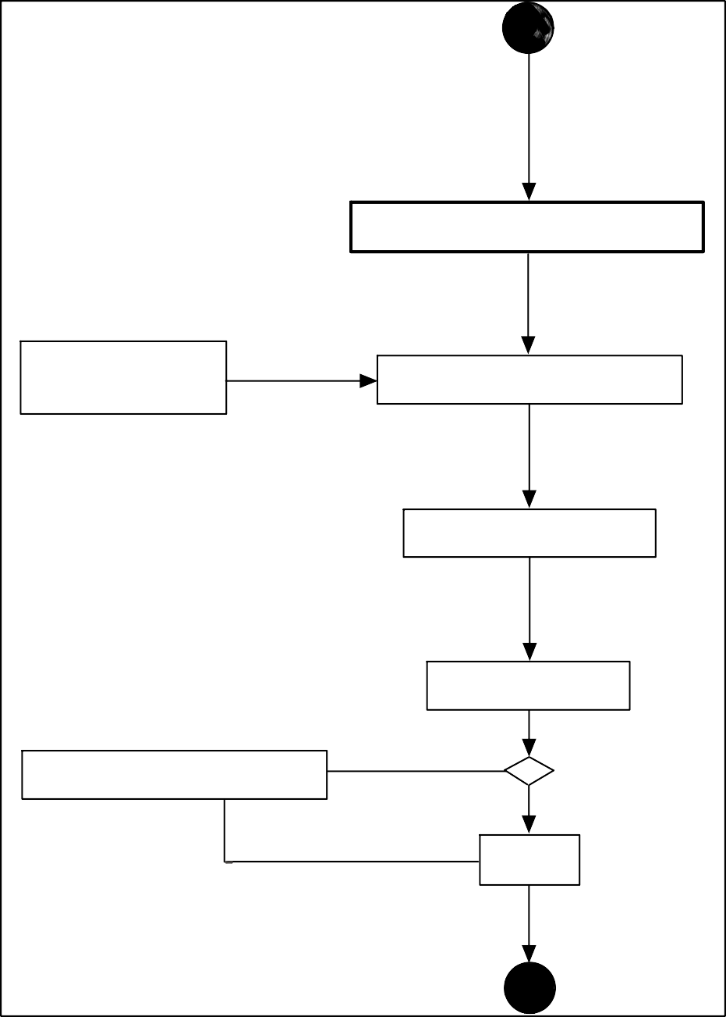

- 6.3 CLASS DIAGRAM:

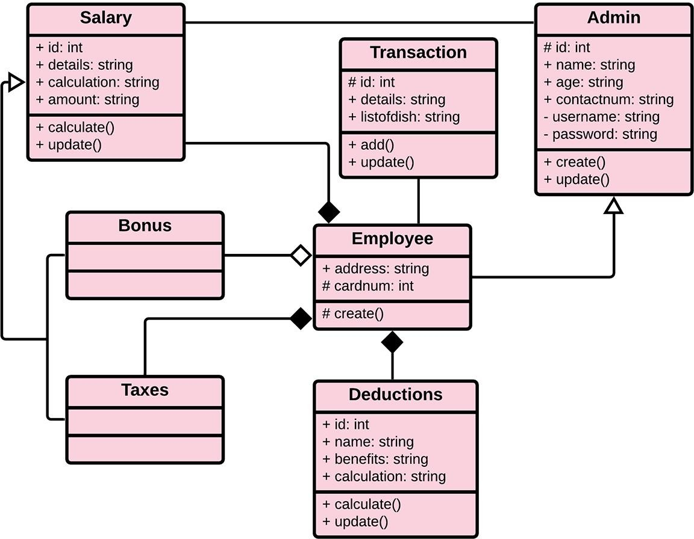

- 6.4 USE CASE DIAGRAM:

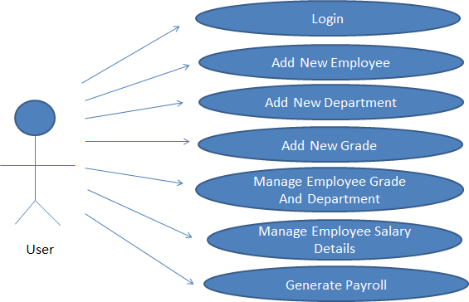

- 6.5 SEQUENCE DIAGRAM:

USER APPLICATION DATABASE
Open application
Enter Login credentials
Successfully logged in
Select required option
Request for required option
Required option selected successfully
Display required page
Insert the required details
Passes entered details
Details entered successfully
Display the details entered
Select record
Request for Report
Display the Report
Report

- 6.6 DATA FLOW DIAGRAM:
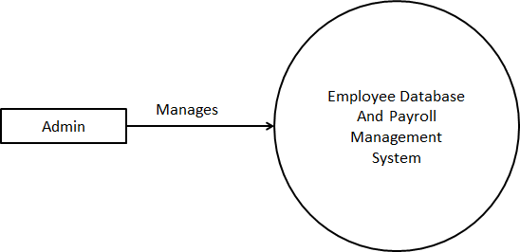
Level 0

Level 1
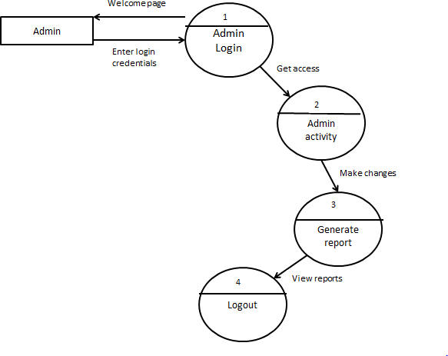

- 6.7 COMPONENT DIAGRAM:

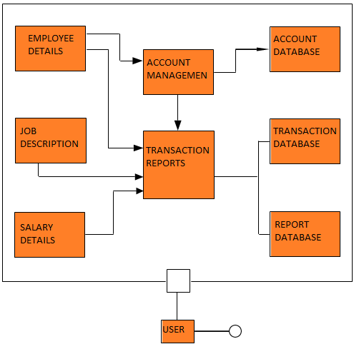

- 6.8 DEPLOYMENT DIAGRAM:

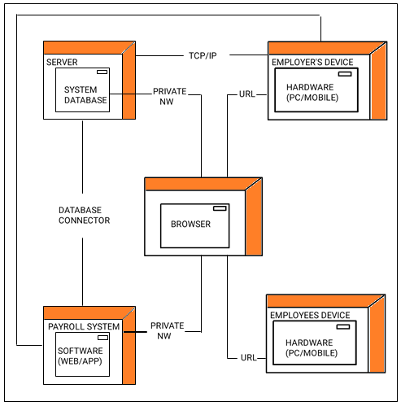

07. Source Code

- SIGN-IN PAGE:-

import { ErrorPopup } from "./error-popup"
import { Link } from "react-router-dom"

export const SignIn = ({ image, handlesigninform, handlesigninsubmit, targetedstate, statevalue, redirectpath }) => {
return (
<>
{targetedstate.error.status ? <ErrorPopup error={targetedstate.error.message} /> : null}
<div className="flex min-h-full flex-1 min-[200px]:flex-col md:flex-row md:items-center justify-center px-6 py-12 lg:px-8 md:gap-5">

<div className="sm:mx-auto sm:w-full sm:max-w-sm lg:mx-10">
<img
alt="Your Company"
src={image}
className="mx-auto h-auto w-auto"
/>
</div>
<div className="my-5 sm:mx-auto sm:w-full sm:max-w-sm lg:mx-10">
<h2 className="mb-5 text-center text-2xl/9 font-bold tracking-tight text-gray-900">
Sign in to your account
</h2>
<form className="space-y-6" onSubmit={handlesigninsubmit}>
<div>
<label htmlFor="email" className="block text-sm/6 font-medium text-gray-900">
Email address
</label>
<div className="mt-2">
<input
id="email"
name="email"
type="email"
required
autoComplete="email"
value={statevalue.email}
onChange={handlesigninform}
className="block w-full rounded-md border-0 py-1.5 text-gray-900 shadow-sm ring-1 ring-inset ring-gray-300 placeholder:text-gray-400 focus:ring-2 focus:ring-inset focus:ring-indigo-600 sm:text-sm/6 p-2"
/>
</div>
</div>

<div>
<div className="flex items-center justify-between">
<label htmlFor="password" className="block text-sm/6 font-medium text-gray-900">
Password
</label>
<div className="text-sm">
<Link to={redirectpath}>
<a className="font-semibold text-indigo-600 hover:text-indigo-500">
Forgot password?
</a>
</Link>
</div>
</div>
<div className="mt-2">
<input
id="password"
name="password"
type="password"
required
autoComplete="current-password"
value={statevalue.password}
onChange={handlesigninform}
className="block w-full rounded-md border-0 py-1.5 text-gray-900 shadow-sm ring-1 ring-inset ring-gray-300 placeholder:text-gray-400 focus:ring-2 focus:ring-inset focus:ring-indigo-600 sm:text-sm/6 p-2"
/>
</div>
</div>

<div>
<button
type="submit"
className="flex w-full justify-center rounded-md bg-indigo-600 px-3 py-1.5 text-sm/6 font-semibold text-white shadow-sm hover:bg-indigo-500 focus-visible:outline focus-visible:outline-2 focus-visible:outline-offset-2 focus-visible:outline-indigo-600"
>
Sign in
</button>
</div>
</form>
</div>
</div>
</>
)

- SIGN-UP PAGE:-

import { ErrorPopup } from "./error-popup"
import { useSelector } from "react-redux"
import { Button } from "@/components/ui/button"
import { Link } from "react-router-dom"

export const SignUP = ({ handlesignupform, handlesubmitform, stateformdata, errorpopup }) => {
const employeestate = useSelector((state) => state.HRReducer)
return (
<>
{employeestate.error.status ? <ErrorPopup error={employeestate.error.message} /> : null}
{errorpopup ? <ErrorPopup error={"Password does not match, Please try again"} /> : null}
<div className="HR-form-content justify-center items-center min-[250px]:w-[90%] 2xl:w-[80%] grid grid-cols-1 min-[900px]:grid-cols-2 mx-auto">

<div className="form-img mx-auto">
<img src="../../src/assets/Employee-Welcome.jpg" alt="Your Company" className=" min-[250px]:max-w-[15rem] min-[600px]:max-w-sm min-[900px]:max-w-sm 2xl:max-w-md" />
</div>

{/* <div className="form-content flex flex-col gap-6 sm:justify-center min-[250px]:items-center sm:items-center md:items-start md:justify-normal">

<div className="form-heading my-3">
<h1 className="text-4xl text-purple-700 font-bold">Sign UP HR</h1>
</div>

<div className="form-content flex gap-8 min-[250px]:flex-col sm:flex-row">

<div className="form-section-first min-[250px]:w-[80vw] sm:w-[30vw] md:w-[20vw] flex flex-col gap-5 sm:text-sm lg:text-md xl:text-lg">

<div className="form-field">
<label htmlFor="firstname" className="block font-medium text-gray-900">
First Name
</label>
<div className="mt-2">
<input
id="firstname"
name="firstname"
type="text"
required
autoComplete="text"
value={stateformdata.firstname}
onChange={handlesignupform}
className="block w-full rounded-md border-0 py-1.5 text-gray-900 shadow-sm ring-1 ring-inset ring-gray-300 placeholder:text-gray-400 focus:ring-2 focus:ring-inset focus:ring-indigo-600 sm:text-sm/6 p-2"
/>
</div>
</div>

<div className="form-field">
<label htmlFor="lastname" className="block font-medium text-gray-900">
Last Name
</label>
<div className="mt-2">
<input
id="lastname"
name="lastname"
type="text"
required
autoComplete="text"
value={stateformdata.lastname}
onChange={handlesignupform}
className="block w-full rounded-md border-0 py-1.5 text-gray-900 shadow-sm ring-1 ring-inset ring-gray-300 placeholder:text-gray-400 focus:ring-2 focus:ring-inset focus:ring-indigo-600 sm:text-sm/6 p-2"
/>
</div>
</div>

- DEPARTMENTTABS:-

import { Button } from "@/components/ui/button"
import {
Card,
CardContent,
CardDescription,
CardFooter,
CardHeader,
CardTitle,
} from "@/components/ui/card"
import { Input } from "@/components/ui/input"
import { Label } from "@/components/ui/label"
import {
Tabs,
TabsContent,
TabsList,
TabsTrigger,
} from "@/components/ui/tabs"
import { Check, ChevronsUpDown } from "lucide-react"

import { cn } from "@/lib/utils"
import {
Command,
CommandEmpty,
CommandGroup,
CommandInput,
CommandItem,
CommandList,
} from "@/components/ui/command"
import {
Popover,
PopoverContent,
PopoverTrigger,
} from "@/components/ui/popover"
import { useState, useEffect } from "react"
import {
DropdownMenu,
DropdownMenuContent,
DropdownMenuItem,
DropdownMenuLabel,
DropdownMenuSeparator,
DropdownMenuTrigger,
} from "@/components/ui/dropdown-menu"
import { useSelector, useDispatch } from "react-redux"
import { HandleGetHRDepartments } from "../../../redux/Thunks/HRDepartmentPageThunk"
import { Loading } from "../loading.jsx"
import { HeadingBar } from "./ListDesigns.jsx"
import { DepartmentListItems } from "./ListDesigns.jsx"
import { useToast } from "../../../hooks/use-toast.js"
import { EmployeesIDSDialogBox } from "./dialogboxes.jsx"

export const HRDepartmentTabs = () => {
const { toast } = useToast()
const HRDepartmentState = useSelector((state) => state.HRDepartmentPageReducer)
const dispatch = useDispatch()
const [department, setdepartment] = useState("All Departments")

const departments = []

if (HRDepartmentState.data) {
for (let index = 0; index < HRDepartmentState.data.length; index++) {
departments.push({
value: HRDepartmentState.data[index].name,
label: HRDepartmentState.data[index].name
})
}
}

useEffect(() => {
if (HRDepartmentState.fetchData) {
dispatch(HandleGetHRDepartments({ apiroute: "GETALL" }))
}

if (HRDepartmentState.error.status) {
toast({
variant: "destructive",
title: "Uh oh! Something went wrong.",
description: `${HRDepartmentState.error.message}`,
})
}

if (HRDepartmentState.success.status) {
toast({
title: <p className="text-xl m-1">Success!</p>,
description: <div className="flex justify-center items-center gap-2">
<img src="../../src/assets/HR-Dashboard/correct.png" alt="" className="w-6" />
<p className="font-bold">{HRDepartmentState.success.message}</p>
</div>,
})
}

console.log("test message")

}, [HRDepartmentState.fetchData, HRDepartmentState.error, HRDepartmentState.success])

useEffect(() => {
dispatch(HandleGetHRDepartments({ apiroute: "GETALL" }))
}, [])

if (HRDepartmentState.isLoading) {
return (
<Loading />
)
}

- FORGOT-PASSWORD:-

import { ErrorPopup } from "./error-popup"
import { useSelector } from "react-redux"
import { Link } from "react-router-dom"

export const ForgotPassowrd = ({ handleforgotpasswordsubmit, handlesforgotpasswordform, targetState, redirectpath }) => {
const EmplyoeeState = useSelector((state) => state.employeereducer)
return (
<>
{targetState.error.status ? <ErrorPopup error={targetState.error.message} /> : null}
<div className="flex min-h-full flex-1 min-[200px]:flex-col md:flex-row md:items-center justify-center px-6 py-12 lg:px-8 md:gap-5">

<div className="sm:mx-auto sm:w-full sm:max-w-sm lg:mx-10">
<img
alt="Your Company"
src="../../src/assets/forgotpassword.png"
className="mx-auto h-auto w-auto"
/>
</div>
<div className="my-5 sm:mx-auto sm:w-full sm:max-w-sm lg:mx-10">
<h2 className="mb-5 text-center text-2xl/9 font-bold tracking-tight text-gray-900">
Enter Your Email Address
</h2>
<form className="space-y-6" onSubmit={handleforgotpasswordsubmit}>
<div>
<label htmlFor="email" className="block text-sm/6 font-medium text-gray-900">
Email address
</label>
<div className="mt-2">
<input
id="email"
name="email"
type="email"
required
autoComplete="email"
onChange={handlesforgotpasswordform}
className="block w-full rounded-md border-0 py-1.5 text-gray-900 shadow-sm ring-1 ring-inset ring-gray-300 placeholder:text-gray-400 focus:ring-2 focus:ring-inset focus:ring-indigo-600 sm:text-sm/6 p-2"
/>
</div>
</div>
<div className="flex flex-col gap-2">
<button
type="submit"
className="flex w-full justify-center rounded-md bg-indigo-600 px-3 py-1.5 text-sm/6 font-semibold text-white shadow-sm hover:bg-indigo-500 focus-visible:outline focus-visible:outline-2 focus-visible:outline-offset-2 focus-visible:outline-indigo-600"
>
Get Reset Email
</button>
<Link to={redirectpath}>
<button
className="flex w-full justify-center rounded-md bg-indigo-600 px-3 py-1.5 text-sm/6 font-semibold text-white shadow-sm hover:bg-indigo-500 focus-visible:outline focus-visible:outline-2 focus-visible:outline-offset-2 focus-visible:outline-indigo-600"
>
Back to Login
</button>
</Link>
</div>
</form>
</div>
</div>
</>
)
}

- LOADING:-

import { ErrorPopup } from "./error-popup"
import { useSelector } from "react-redux"
import { Link } from "react-router-dom"

export const ForgotPassowrd = ({ handleforgotpasswordsubmit, handlesforgotpasswordform, targetState, redirectpath }) => {
const EmplyoeeState = useSelector((state) => state.employeereducer)
return (
<>
{targetState.error.status ? <ErrorPopup error={targetState.error.message} /> : null}
<div className="flex min-h-full flex-1 min-[200px]:flex-col md:flex-row md:items-center justify-center px-6 py-12 lg:px-8 md:gap-5">

<div className="sm:mx-auto sm:w-full sm:max-w-sm lg:mx-10">
<img
alt="Your Company"
src="../../src/assets/forgotpassword.png"
className="mx-auto h-auto w-auto"
/>
</div>
<div className="my-5 sm:mx-auto sm:w-full sm:max-w-sm lg:mx-10">
<h2 className="mb-5 text-center text-2xl/9 font-bold tracking-tight text-gray-900">
Enter Your Email Address
</h2>
<form className="space-y-6" onSubmit={handleforgotpasswordsubmit}>
<div>
<label htmlFor="email" className="block text-sm/6 font-medium text-gray-900">

- RESET-EMAIL-CONFIRM:-

import { Link } from 'react-router-dom'
export const ResetEmailConfirmaction = ({ redirectpath }) => {
return (
<div className="email-reset-container h-[100vh] flex justify-center items-center">
<div className="reset-email-conetent flex min-h-full flex-1 min-[200px]:flex-col md:flex-row md:items-center justify-center px-6 py-12 lg:px-8 md:gap-5">
<div className="reset-email-img sm:mx-auto sm:w-full sm:max-w-sm lg:mx-10">
<img src="../../src/assets/sendemail.png" alt="Send-Email" className="mx-auto h-auto w-auto" />
</div>
<div className="reset-email-content my-5 sm:mx-auto sm:w-full sm:max-w-sm lg:mx-5 md:w-full flex flex-col justify-center min-[200px]:text-center md:text-start min-[200px]:items-center md:items-start gap-3">
<p className="md:text-lg text-green-600 font-bold sm:text-sm lg:text-xl">We have successfully send you a Reset email, Click on The Reset Password To Reset Your Password.</p>
<p className="md:text-lg text-red-600 font-bold sm:text-sm lg:text-xl">Please do not forward reset passowrd email</p>
<div className="back-login-button">
<Link to={redirectpath} className="flex w-full justify-center rounded-md bg-indigo-600 px-3 py-1.5 text-sm/6 font-semibold text-white shadow-sm hover:bg-indigo-500 focus-visible:outline focus-visible:outline-2 focus-visible:outline-offset-2 focus-visible:outline-indigo-600">
Back to Login
</Link>
</div>
</div>
</div>
</div>
)
}

- Reset-Password:-

import { Link } from "react-router-dom"
import { ErrorPopup } from "./error-popup"
import { useSelector } from "react-redux"
export const Reset_Password = ({ handlepasswordsubmit, handlepasswordform, passworderror, targetstate }) => {
return (
<>
{targetstate.error.status ? <ErrorPopup error={targetstate.error.message} /> : null}
{passworderror ? <ErrorPopup error={"Password Does Not Match, Please Try Again"} /> : null}
<div className="flex min-h-full flex-1 min-[200px]:flex-col md:flex-row md:items-center justify-center px-6 py-12 lg:px-8 md:gap-5">

08. Screen Short

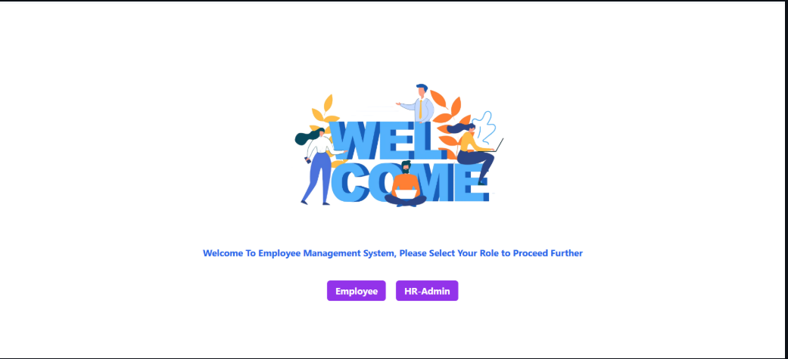
- EMS Entry Page:

- EMS HR Sign Up:
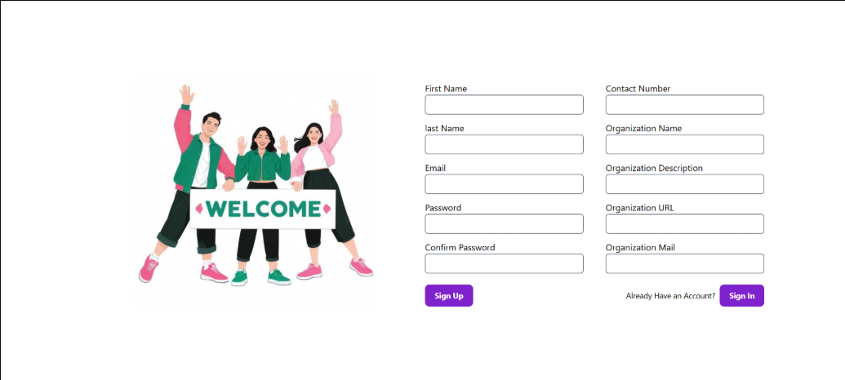

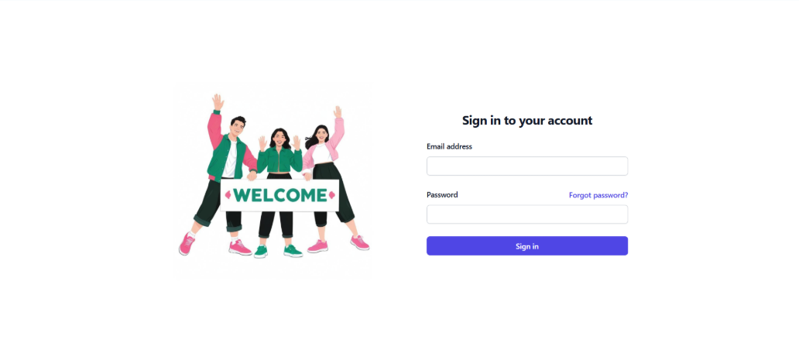
- EMS HR Login:

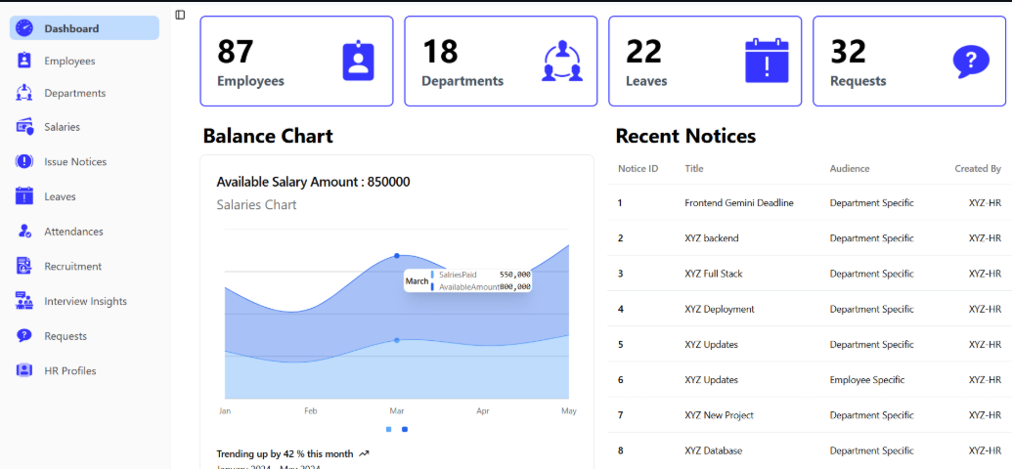
- EMS HR Dashboard:

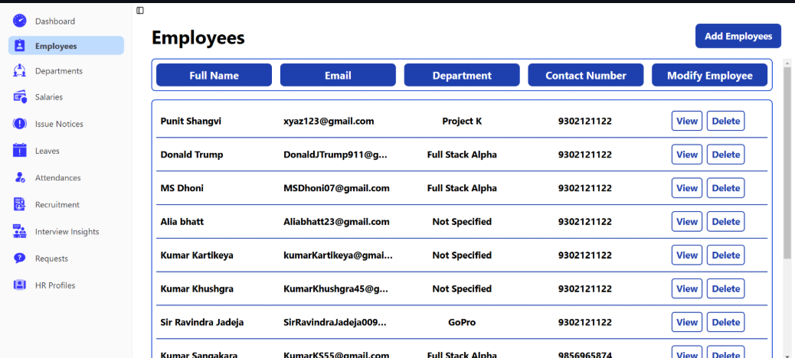
- EMS HR Employees Page:

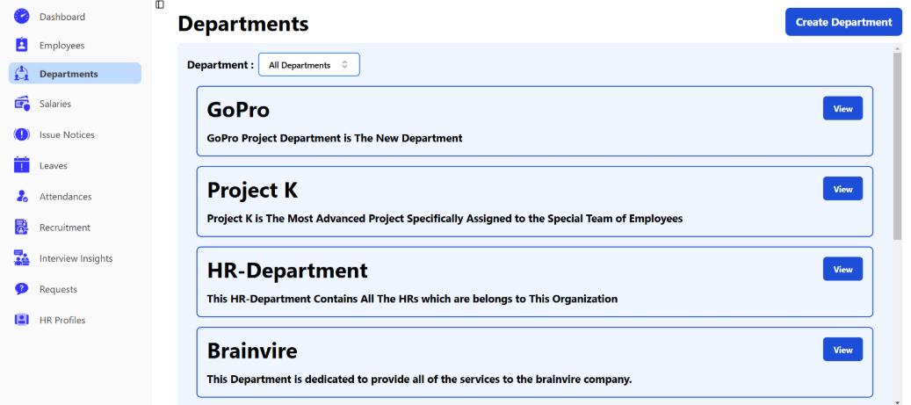
- EMS HR Departments Page:

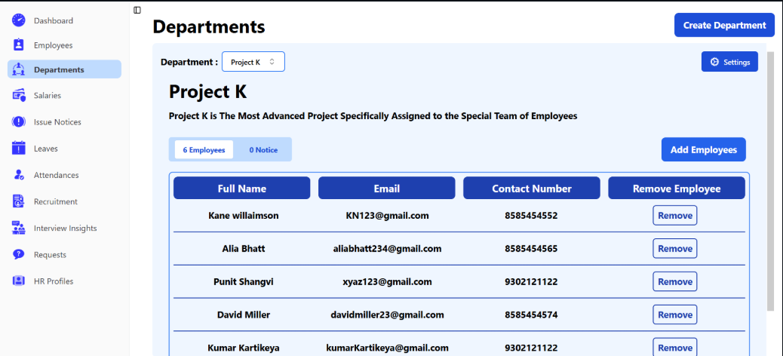
- EMS HR Departments Data:

09. FEATURES OF THE PROJECT

- Easy to use.
- It is completely secure.
- It is completely controlled by admin.
- This system is easily compatible with most of the web browsers.
- It is very interactive and save time.
- Reduces paper works.
- Calculations are automated so it is highly accurate.
- Targets & Milestones for guiding the programmers.
- Attachments & Additional Comments for more information.
- Admin and staff can view all the records whenever necessary with ease.
- Various level of report available with a lot of filters criteria.
- Easy to update information.

10. FUTURE SCOPE OF THIS WORK

- The option to print records in the future.
- I intend to add a leave structure in the future.
- I would like to implement a regular backup mechanism to back up the employee
- Database to avoid disasters.
- The system can be developed in such a way that its existing features can
- Be modified to better versions.

11. CONCLUSION

This project is built keeping in mind that it is to be used by only one user that is the admin. It is built for use in small scale organization where the number of employees is limited. According to the requested requirement the admin can add, manipulate, update and delete all employee data in his organization.

The admin can add new departments and delete them. The Admin can also add predefined pay grades for the employees. The required records can be easily viewed by the admin anytime time he wants in an instant. The payment of the employee is based on monthly basis.

Numerous validations implemented would enable the admin to enter accurate data. The main objective of this framework is to save time, make the system cost effective and management records efficiently.

12. BIBLIOGRAPHY

Websites:

www.w3schools.com

www.tutorialspoint.com

www.youtube.com

